Ethernet Frame

🧱 What Is an Ethernet Frame?
# Source: Chatgpt (GPT‑5 Mini) at [12/14/2025]
An Ethernet frame is the basic data unit used to carry data across Ethernet networks (LANs). It encapsulates network-layer packets (like IP packets) so they can be transmitted between devices using MAC addresses on the Data Link Layer (OSI Layer 2).

🧠 Simple Definition:
# Source: Chatgpt (GPT‑5 Mini) at [12/14/2025]
An Ethernet frame is a structured block of data that contains everything needed to send information from one device to another on a local network — including source/destination MAC addresses, the actual data, and error-checking info.

🧾 Ethernet Frame Format
# Source: Chatgpt (GPT‑5 Mini) at [12/14/2025]
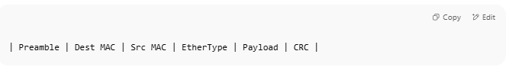
| Preamble | Dest MAC | Src MAC | EtherType | Payload | CRC |

📦 Full Breakdown of Ethernet II Frame
# Source: Chatgpt (GPT‑5 Mini) at [12/14/2025]
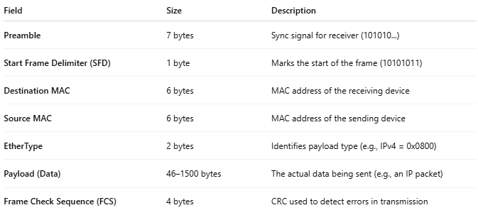

Field | Size | Description
Preamble | 7 bytes | Sync signal for receiver (101010...)
Start Frame Delimiter (SFD) | 1 byte | Marks the start of the frame (10101011)
Destination MAC | 6 bytes | MAC address of the receiving device
Source MAC | 6 bytes | MAC address of the sending device
EtherType | 2 bytes | Identifies payload type (e.g., IPv4 = 0x0800)
Payload (Data) | 46–1500 bytes | The actual data being sent (e.g., an IP packet)
Frame Check Sequence (FCS) | 4 bytes | CRC used to detect errors in transmission

🧱 Ethernet Frame Format Example (Ethernet II)
# Source: Chatgpt (GPT‑5 Mini) at [12/14/2025]
🧾 Let's assume we are sending a simple HTTP request from a PC to a web server.

📦 Frame Structure:
# Source: Chatgpt (GPT‑5 Mini) at [12/14/2025]
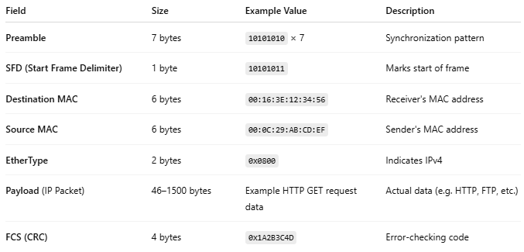
Field | Size | Example Value | Description
Preamble | 7 bytes | 10101010 × 7 | Synchronization pattern
SFD (Start Frame Delimiter) | 1 byte | 10101011 | Marks start of frame
Destination MAC | 6 bytes | 00:16:3E:12:34:56 | Receiver's MAC address
Source MAC | 6 bytes | 00:0C:29:AB:CD:EF | Sender's MAC address
EtherType | 2 bytes | 0x0800 | Indicates IPv4
Payload (IP Packet) | 46–1500 bytes | Example HTTP GET request data | Actual data (e.g. HTTP, FTP, etc.)
FCS (CRC) | 4 bytes | 0x1A2B3C4D | Error-checking code

🧠 Visual Example (Hex View)
# Source: Chatgpt (GPT‑5 Mini) at [12/14/2025]
Here's what this might look like in hexadecimal, simplified:
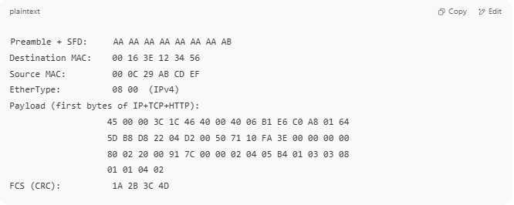
Preamble + SFD: AA AA AA AA AA AA AA AB
Destination MAC: 00 16 3E 12 34 56
Source MAC: 00 0C 29 AB CD EF
EtherType: 08 00 (IPv4)
Payload (first bytes of IP+TCP+HTTP):
45 00 00 3C 1C 46 40 00 40 06 B1 E6 C0 A8 01 64
5D B8 D8 22 04 D2 00 50 71 10 FA 3E 00 00 00 00
80 02 20 00 91 7C 00 00 02 04 05 B4 01 03 03 08
01 01 04 02
FCS (CRC): 1A 2B 3C 4D

🌐 Payload Details (example content)
# Source: Chatgpt (GPT‑5 Mini) at [12/14/2025]
This part might contain:
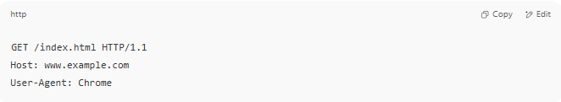
GET /index.html HTTP/1.1
Host: www.example.com
User-Agent: Chrome

Encoded as part of the IP packet, which itself is inside the Ethernet frame.

✅ Summary
# Source: Chatgpt (GPT‑5 Mini) at [12/14/2025]
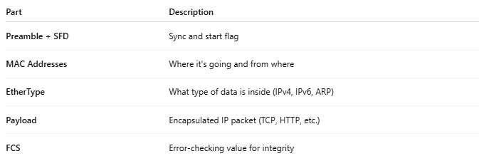
Part | Description
Preamble + SFD | Sync and start flag
MAC Addresses | Where it's going and from where
EtherType | What type of data is inside (IPv4, IPv6, ARP)
Payload | Encapsulated IP packet (TCP, HTTP, etc.)
FCS | Error-checking value for integrity

📌 Minimum and Maximum Ethernet Frame Sizes
# Source: Chatgpt (GPT‑5 Mini) at [12/14/2025]
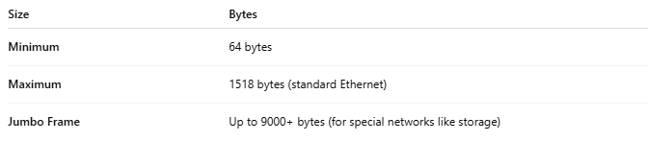

Size | Bytes
Minimum | 64 bytes
Maximum | 1518 bytes (standard Ethernet)
Jumbo Frame | Up to 9000+ bytes (for special networks like storage)

📡 What Ethernet Frames Are Used For
# Source: Chatgpt (GPT‑5 Mini) at [12/14/2025]
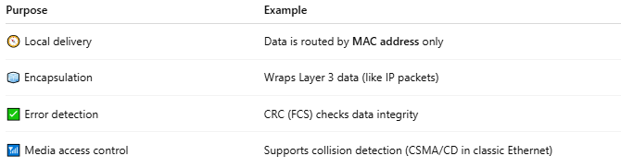

Purpose | Example
🧭 Local delivery | Data is routed by MAC address only
🧊 Encapsulation | Wraps Layer 3 data (like IP packets)
✅ Error detection | CRC (FCS) checks data integrity
📶 Media access control | Supports collision detection (CSMA/CD in classic Ethernet)

🆚 Frame vs Packet
# Source: Chatgpt (GPT‑5 Mini) at [12/14/2025]
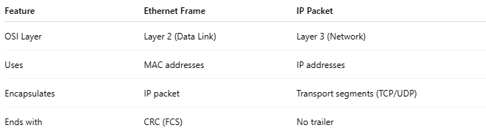

Feature | Ethernet Frame | IP Packet
OSI Layer | Layer 2 (Data Link) | Layer 3 (Network)
Uses | MAC addresses | IP addresses
Encapsulates | IP packet | Transport segments (TCP/UDP)
Ends with | CRC (FCS) | No trailer

🖼️ Diagram
# Source: Chatgpt (GPT‑5 Mini) at [12/14/2025]
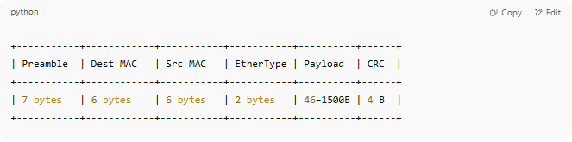
+-----------+------------+-----------+-----------+----------+------+
| Preamble | Dest MAC | Src MAC | EtherType | Payload | CRC |
+-----------+------------+-----------+-----------+----------+------+
| 7 bytes | 6 bytes | 6 bytes | 2 bytes | 46–1500B | 4 B |
+-----------+------------+-----------+-----------+----------+------+

✅ Summary
# Source: Chatgpt (GPT‑5 Mini) at [12/14/2025]
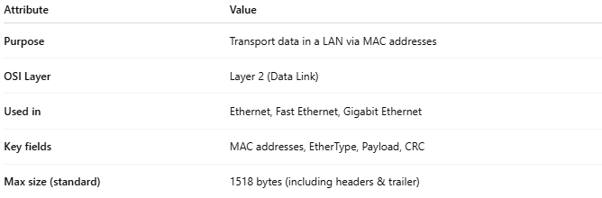
Attribute | Value
Purpose | Transport data in a LAN via MAC addresses
OSI Layer | Layer 2 (Data Link)
Used in | Ethernet, Fast Ethernet, Gigabit Ethernet
Key fields | MAC addresses, EtherType, Payload, CRC
Max size (standard) | 1518 bytes (including headers & trailer)

